LARAVEL GUIDELINE

STEP 1 :: Composer install :: If composer not install, composer installation is required.
Go to the https://getcomposer.org/download/ link.
Download from the below screen
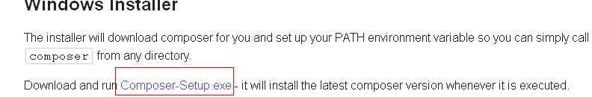

Install the setup file into the system and set the path during the installation to the php.exe path.
E.g. D:\xampp\php
Click next next to complete the Composer installation.

STEP 2 :: Command prompt command to download the laravel files.

Open command prompt.
cd “open the path of the xampp htdocs folder/ project name ”

Install the laravel composer via command promt
“composer global require "laravel/installer=~1.1"
”

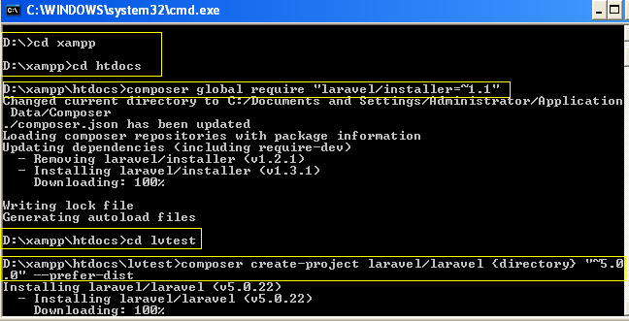

from the above picture the laravel installation process can be identified.
Download the laravel composer.
Go to the folder where the laravel files need to be installed.

Or run the command “composer create-project laravel/laravel {directory} "~5.0.0" --prefer-dist
”
Instead of creating the folder before we can create the folder in the above command in place of {directory}. Replace {directory} with lvtest or your wish folder name.

Once the installation and download completed below screen will come.

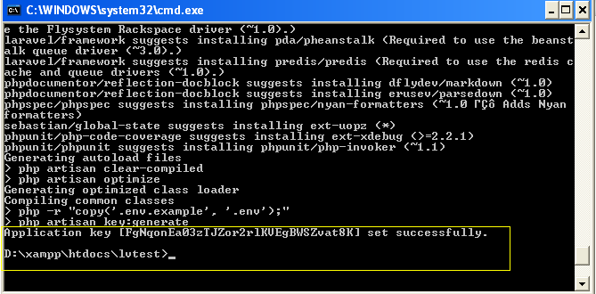

The screen suggests that the laravel installation has been done successfully.

FOLDER STRUCTURE ::

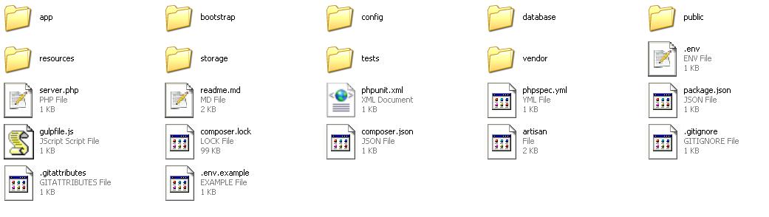

CONFIGUREATION :: .env file where all the configuration related settings are there.

Folder “app” where all the code related files are kept.
Folfer “resources” where all the extra files or view files are kept.

In view folder all the view files should be written in below format.

Home.blade.php -> Home is the view name to call and blade.php is the extension to append on all the view files.

ROUTS ::

To call a function link means in browser.
http://lvtest.com/home means in routs.php home definition has been written.
The link execute the “home controller” and “index” function.
Route::get('home', 'HomeController@index');

The localhost link can be changed to your by declaring it in virtual host.
Check the below para.

<VirtualHost *:80>
ServerAdmin larvel5.com
DocumentRoot "F:/xampp/htdocs/larvel5/public"
ServerName larvel5.com
ErrorLog "logs/dummy-host2.example.com-error.log"
CustomLog "logs/dummy-host2.example.com-access.log" common
</VirtualHost>

copy above and go to xampp/apache/conf/extra/httpd-vhost.conf

After that go to os/windows/system32/driveres/etc/hosts edit file and after that restart the apache.

LARAVEL COMMON SECTION

- Create new service provider
- Then include in app.php.
- Then follow this link (http://stackoverflow.com/questions/28608527/how-to-pass-data-to-all-views-in-laravel-5)

LARAVEL Social Login (http://goodheads.io/2015/08/24/using-facebook-authentication-for-login-in-laravel-5/)

Using Facebook Authentication For Login in Laravel 5

Laravel has simplified authentication processes either the traditional way or via social media like Facebook, Twitter, LinkedIn or Github by creating a Laravel Socialite Package.
Let’s see how we can utilize this package for Facebook Authentication:
1. Do a clean install of Laravel 5
2. Install Socialite

1 | composer require laravel/socialite
3. Head over to your config/app.php and add the following in the providers array:

1 | Laravel\Socialite\SocialiteServiceProvider::class
4. Still in your config/app.php file, also add this to the aliases array:

1 | 'Socialite' => Laravel\Socialite\Facades\Socialite::class
We just registered a Facade for Laravel Socialite.
5. Create Facebook app.
Head over to Facebook Developers Page . Under the My apps, there is a link to create a new app.
A dialog box should appear afterwards showing you different options, Choose Website since we are building a web app. So give your app a name and click “Create new Facebook App ID”.
I named mine “Laravel Auth”.
Another dialog box should appear. Choose the Category. I chose “Education” for the purpose of this tutorial.
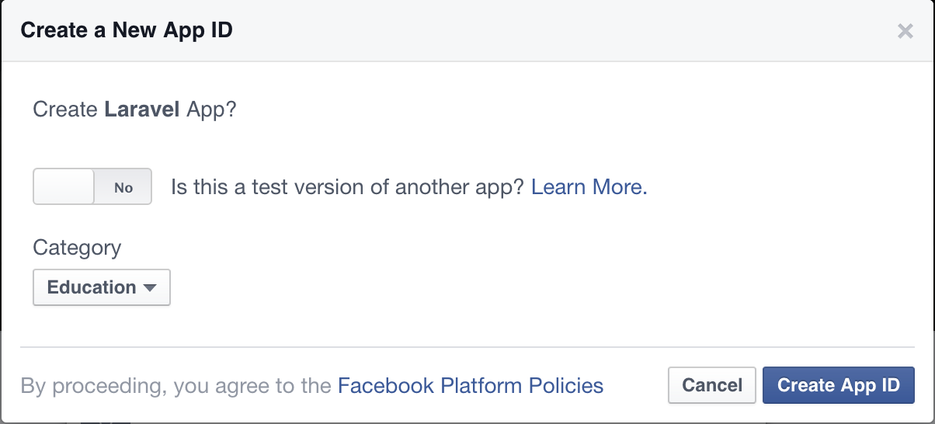

Go ahead and create App ID.
Click on Facebook Login when you scroll down here:
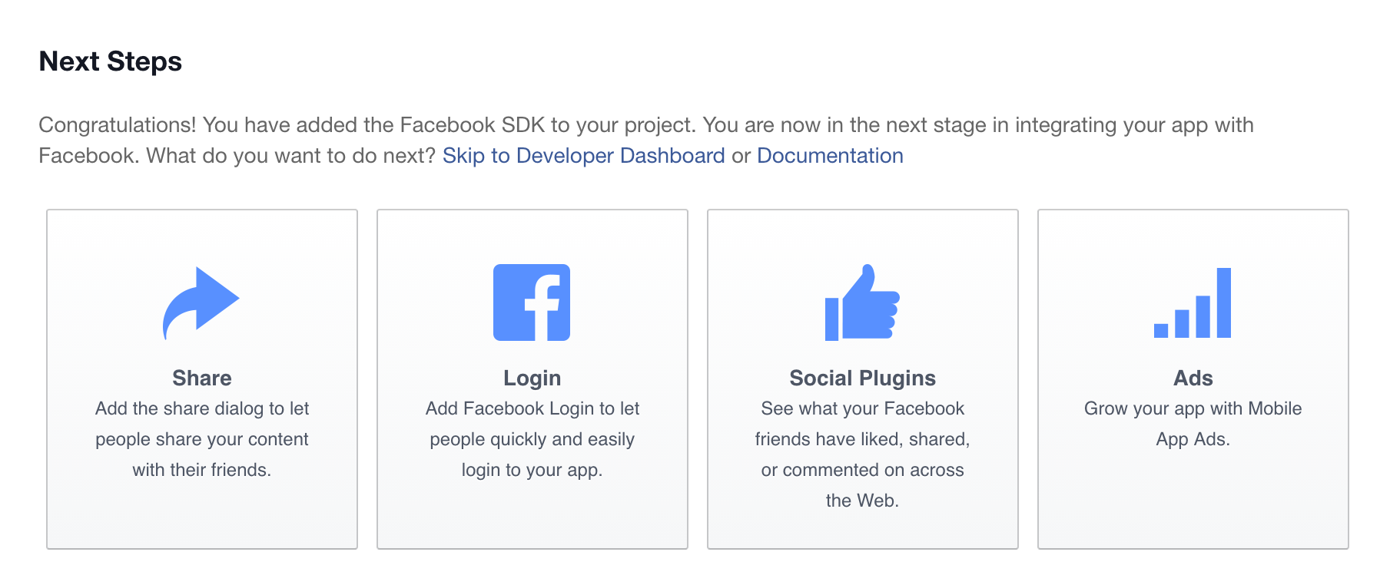

6. Add Facebook Config
Head over to your config/services.php and add this:

1  2  3  4  5 | 'facebook' => [  'client_id' => env('FACEBOOK_CLIENT_ID'),  'client_secret' => env('FACEBOOK_CLIENT_SECRET'),  'redirect' => env('CALLBACK_URL'),  ],
Open your .env file and add your facebook client id, secret and callback url like so:

1  2  3 | FACEBOOK_CLIENT_ID=xxxxxxxxx  FACEBOOK_CLIENT_SECRET=xxxxxxx  CALLBACK_URL=http://localhost:8000/auth/facebook/callback
where xxxxxxx refers to your APP ID and APP secret. You can find those details when you click on the name of your app in the dropdown that “My apps” provides on the facebook developer dashboard page.
7. Set up Routes and Controller Methods
You will need two routes: one for redirecting the user to the OAuth provider, and another for receiving the callback from the provider after authentication.
Add these to routes.php

1  2 | Route::get('auth/facebook', 'Auth\AuthController@redirectToProvider');  Route::get('auth/facebook/callback', 'Auth\AuthController@handleProviderCallback');
Let’s Open up our AuthController.php file in Auth folder and add this:

1  2  3  4  5  6  7  8  9  10  11  12  13  14  15  16  17  18  19  20  21  22  23  24  25  26  27  28  29  30  31  32  33  34  35  36  37  38  39  40  41  42  43  44  45  46  47  48  49  50  51  52  53 | protected $redirectPath = '/home';  /**  * Redirect the user to the Facebook authentication page.  *  * @return Response  */  public function redirectToProvider()  {  return Socialite::driver('facebook')->redirect();  }  /**  * Obtain the user information from Facebook.  *  * @return Response  */  public function handleProviderCallback()  {  try {  $user = Socialite::driver('facebook')->user();  } catch (Exception $e) {  return redirect('auth/facebook');  }  $authUser = $this->findOrCreateUser($user);  Auth::login($authUser, true);  return redirect()->route('home');  }  /**  * Return user if exists; create and return if doesn't  *  * @param $facebookUser  * @return User  */  private function findOrCreateUser($facebookUser)  {  $authUser = User::where('facebook_id', $facebookUser->id)->first();  if ($authUser){  return $authUser;  }  return User::create([  'name' => $facebookUser->name,  'email' => $facebookUser->email,  'facebook_id' => $facebookUser->id,  'avatar' => $facebookUser->avatar  ]);  }
Note: Add the Socialite and Auth class reference at the top of this file like so:

1  2 | use Auth;  use Socialite;

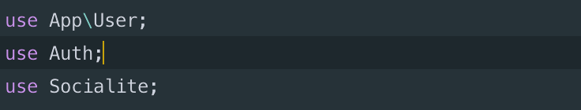
First, it redirects to Facebook, grabs the relevant information and then looks up the user and authenticate as that user. If the user doesn’t exist, it creates the user and authenticate.
8. Database
We need to update our users migration so that it will allow us to store facebook-specific information. Since this is a new app, I could just modify the users migration, but if you have an existing app, you’ll need to make a new migration.
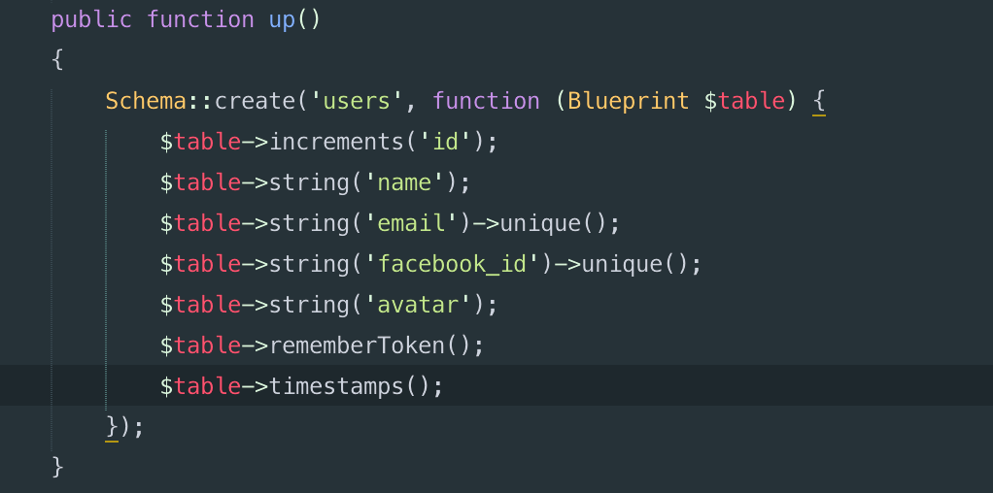
Now let’s get to work.
Head over to your welcome.php and edit it to have a login facebook button like so:
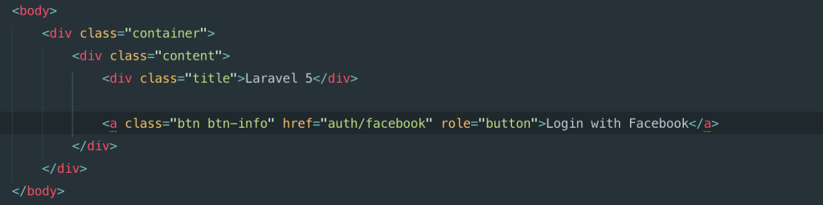
Don’t forget to link the file with bootstrap.
In your routes.php, add this:

1  2  3 | Route::get('home', array('as' => 'home', 'uses' => function(){  return view('home');  }));
Create home.blade.php
Copy the contents of welcome.blade.php into it and just update the body content to have this:
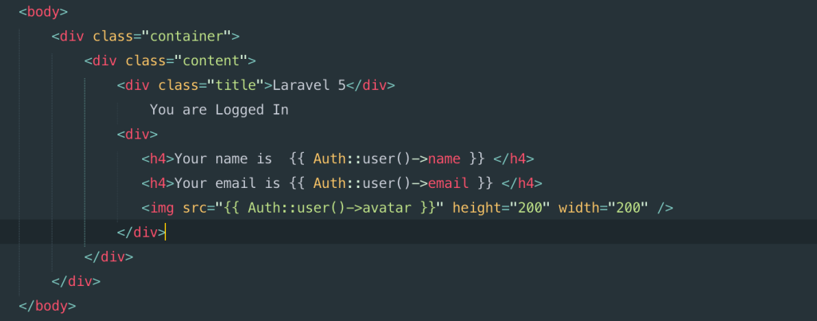
Now, run your migrations lest we forget like so:

1 | php artisan migrate
Are you ready to test your app?..after all the work!

Now, run php artisan serve and click on the Login with Facebook button on your homepage
